Properties of continuous time Fourier Series

Department of Computer Systems Engineering

University of Engineering and Technology, Peshawar

**Lab Report # 11**

CSE301 - L Signals & Systems Lab

Submitted by: Awais Saddiqui

Registration No: 21PWCSE1993

Class Section: A

**Submitted to:**

Dr Durre-Nayab

Properties of Continuous Time Fourier Series



* **Linearity:**

Given two periodic signals x(t) and y(t) having same period, linearity property of FS representation can be expressed as**:**

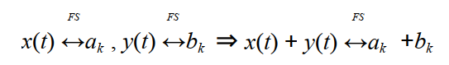

* **Time Shifting:**

The time shifting property of FS states that.

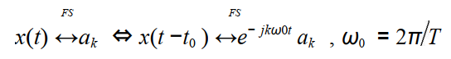

* **Time Reversal:**

The time reversal property of FS states that.

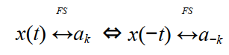

* **Time Scaling:**

The time scaling property of FS states that.

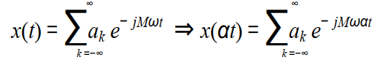

Lab Objectives

* This lab aims at the understanding of the properties of CT Fourier Series  
  • Linearity  
  • Time Shifting  
  • Time Scaling  
  • Time Reversal

TASk #01

* Problem Statement:

Given the signal x(t) with ak’s  
a) Plot the time reverse version of the signal x(‐t) directly,  
b) Plot FS coefficients a‐k of time reversed signal,  
c) Plot the reconstructed time reversed signal using FS coefficients a‐k

* 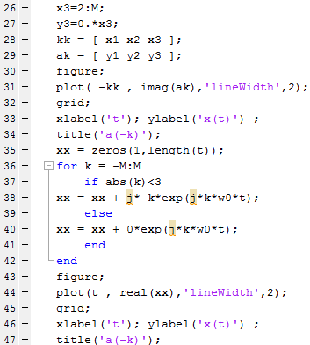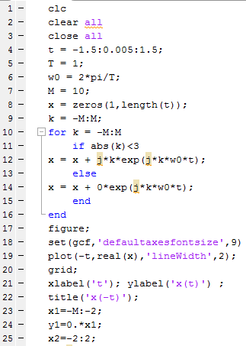Code & Output:

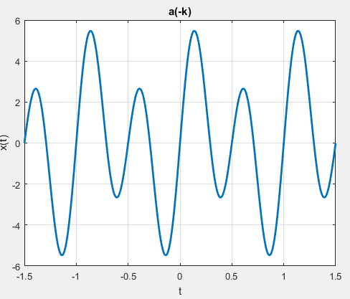

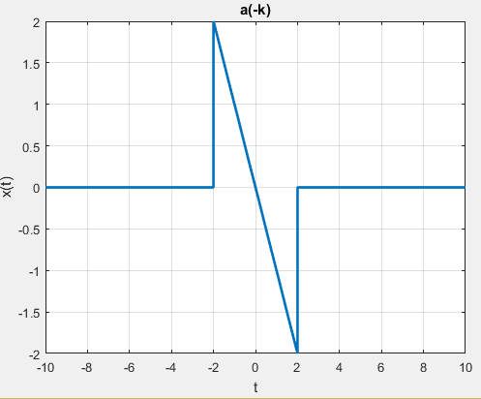

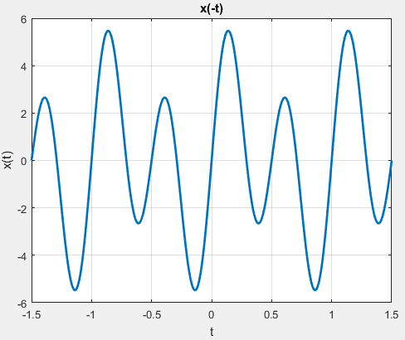

TASK # 02

* Problem Statement:

Given the periodic square wave x(t) with T = 1 & T1 = 0.25, rewrite the above code for time scaling when value of alpha is 2 i.e. x(αt) = x(2t).

* Code & Output:

